Text Vectorization:

Text vectorization is a technique of generating numerical feature vectors corresponding to the terms in a text document[]. With an assumption that any target or dependent variable is a function of text document that is associated with the variable, text document is also considered as independent variable. Because machine learning algorithm does not process raw strings of text to generate an estimator, a text document needs to be vectorized.

Basically there are two methods of translating a document to it's corresponding numerical vectors: 1)Term Frequency Vectors and 2) Term Frequency-Inverse Document Frequency Vectors

Term Frequency Vectors is generated by counting occurrences of a particular term or word in the document, which is called term frequency. For example, if a term t occurs for a frequency of f then the vector value for the term is v = f.

In general, for term Ti that exists in a document Dj, a term frequency vector is Vj, an array of all fi.
Term frequency Vector approach emphasizes frequent terms however it diminishes the rare terms which are empirically more informative than the higher frequency terms[Christian]. In a classification problem[Christian], highly frequent terms what are present in the entire corpus of the documents would be less benificial. This problem of term frequency is solved by term tf-idf weight that is used to generate term-frequency-inverse document frequency vectors.

Term-frequency-inverse Document Frequency Vectors:

Let a document be defined as D= {d1, d2,..,dn}, where n is the number of documents in a corpus C. Then IDF(t) of a term t is defined as:
IDF(t) = log[Magnitude(D)/(1+Nt), Nt is the number of documents where the term t appears, when tf(t,d) is non zero. Function TF-IDF(t) is defined as:
TF-IDF(t) = tf(t,d) x IDF(t) (2)
Steps for vectorization:

Text vectorization consists of three specific techniques: 1) Tokenization, 2) Counting, and 3) Norm alization. Tokenization is process of segregating a document into different components called words or terms and assigning each token an integer id. Each word or term is called a token. To tokenize a given document, separators like white-spaces, punctuation marks could be used. Counting is a process of counting the occurances of terms or words and assigning frequencies to them. Token Normalization is method by which each of the vectors corresponding to a document is expressed to have magnitude of unity. In general, if v is a vector space, normalized vector is obtained by dividing 'v' by its magnitude |v|. There are normal forms: L2-norm, and L1-norm.

Attributes that Needed Vectorization:

Three attributes of an application needed vectorization. are:

- Name: It is name of an application. It consists of text of small length in multiple language.
- Description: It is textual description of an application. It consists of multiple words of bigger lengths, and could contain words of multiple languages.
- Category: It represents a category that an application could belong to. There are 41 different categorical names and all belong to English terms.

Methods used for vectorization inignored. this project:

Basically two types of vectorization method is used. In first method, Sklearn's CountVectorizer with stop words in languages English, German, Arabic was used. In second method, CustomStemVectorizer with stop words in languages English, German, Arabic was used. Later method produces stem of the words in the document by employing Nltk's stemmer. In both of the cases, token that represents numerical values, punctuations and other symbols in {*, _} are ignored by the vectorizers.

Analysis of Sparsity of the Vectorized Features

Sparsity of a vectorized matrix is ratio of total non zero values to total values in the matrix. Sparsity decreases as number of terms having zero term frequency incerases. High sparsity of a vectorized matrix is desired.

Two different vectorization ways are implemented for the above attributes of the applications. Fo each of the following vectorizations, stops word of languages like English, Russina, Greek, Latin, Chinese, Japanese, Korean and Arabian are used to disregard syntactically redundant words in the languages. However, more than 30 languages appear across the documents describing description of the application. Numerical terms that appear in description and that represent year or price or number of installations, and so on are excluded consciously to reduce the size of the vectorized matrix.

- Stemmed Vectorization:

In stemmed vectorization, stem or root of the the word are generated for every word that appears in a document. This reduces the size of feature vectors because two or more words having same stem are excluded. In this case, stemmer utility of NLTK python library is used to determine stem of an English word. Stemmer utilities for other languages could be also be used.

- Unstemmed Vectorization:

In unstemed vectorization, each word is counted as single token and no stemming of the word is performed. This approach significantly increases the size of vectorized matrix as each words represents an unique feature irrespective of their origin or root.

Both vectorization techniques were to process the text describing name, description and category of applications and the the sparsity of the matrix generated is ocompared. Languages were grouped into two categories: 1. Pure English words and 2. English including all other languages. In each case, stemmer for English words were used, and stop words used were of English, Russian, Arabic, Japanese, Korean, Chinese. With sample size of 10Kapplications, following result of sparsity is obtained.

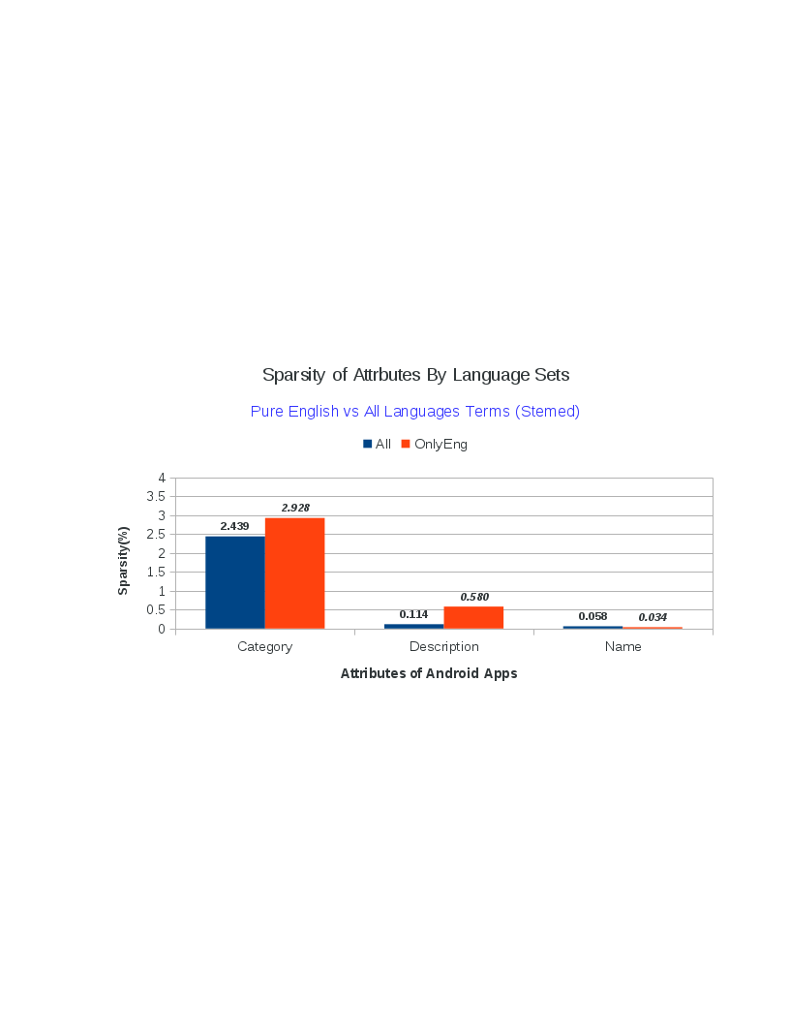
References:

http://scikit-learn.org/stable/modules/feature_extraction.html
Christian: http://blog.christianperone.com/2011/10/machine-learning-text-feature-extraction-tf-idf-part-ii/

